# Art Therapy: How to Draw a Stick-Figure Comic

by [Monika Zagrobelna](https://tutsplus.com/authors/monika-zagrobelna)13 Nov 2017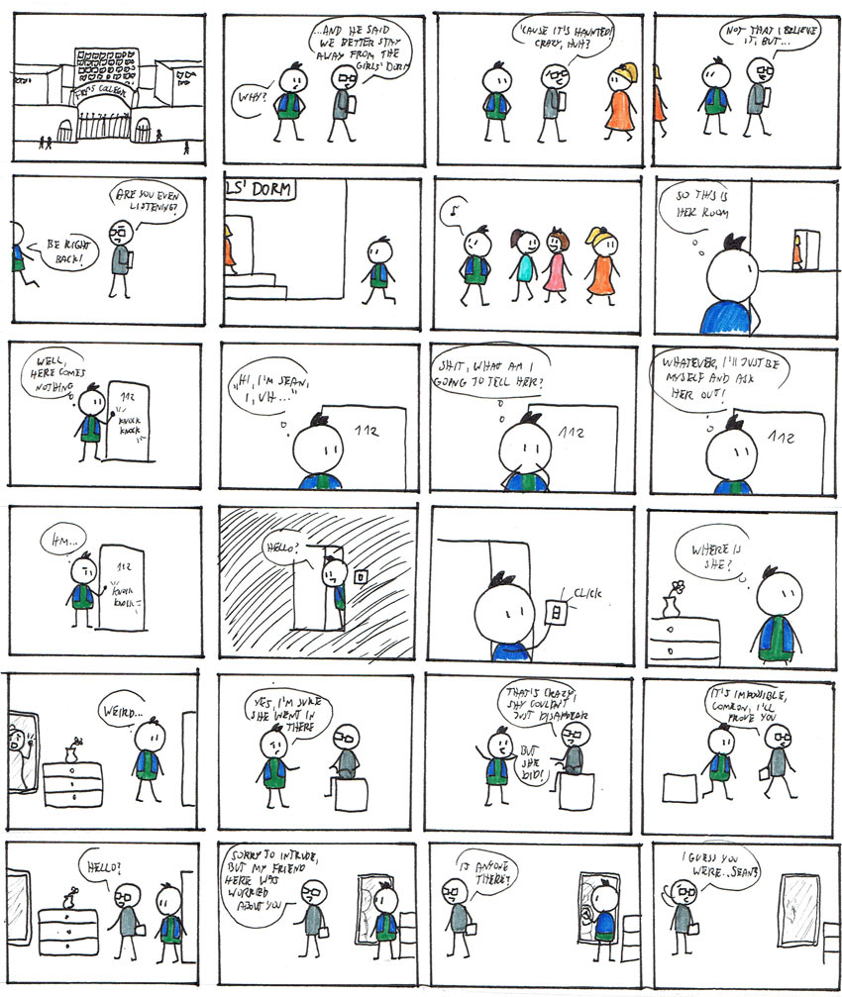What You'll Be Creating

Most people are creative in one way or another. Even though not all of us become artists or writers, it doesn't mean we can't create some stories in our minds. We just usually don't feel confident enough to share them with others, or even put them to paper just for us to see. We feel they're silly, not good enough, just a piece of garbage in comparison to what some other people produce.

But creating a story, no matter how silly, can be very fun! We can't really fathom the whole potential of it until we let it unwind. The characters become alive as the story moves forward, helping you create it along the way. A new world appears before your eyes, full of unique people with their problems and desires. They wouldn't exist without you, and it gives you an amazing sense of power.

I believe anyone can create their own story. Writing is difficult, but there's a medium that works in a more intuitive, visual way: comics. And you don't need to be skilled at drawing to create them, either!

This tutorial is part of the series Art Therapy. It teaches you how to use art for relaxation and fun without putting too much pressure on yourself.

* [[](https://design.tutsplus.com/articles/art-therapy-what-it-is-and-how-it-may-help-you--cms-29466)](https://design.tutsplus.com/articles/art-therapy-what-it-is-and-how-it-may-help-you--cms-29466)

## What You Will Need

You can use any tools you have lying around, but I recommend:

* some sheets of paper
* pencil
* ink liner/fine liner
* colorful felt-tip markers
* long ruler
* eraser

## Why Everyone Can Create Comics

The world we see is full of details, but we rarely notice them all. It's more efficient to think in symbols: a quick representation of an object including only the most prominent features of it. So you can draw a human by carefully rendering every angle of their face, every shade on their hair, and every muscle bulging under their skin, but you can also draw a few roughly straight lines—and both will be recognized as a human.

Yes, the former requires more skill, and thus is certainly more impressive. But it doesn't mean that a stick figure is "wrong", "ugly", or "not good enough". It's perfectly good enough for so many purposes!

Look at these ancient drawings of people. They have no visible human anatomy, not to mention the ridiculous proportions of barely recognizable body parts. But it doesn't matter. The point of these "artworks" was to picture a certain scene, and that purpose was fulfilled. Giving these humans more detailed features would maybe make them "prettier", but it wouldn't really make the scene any better.

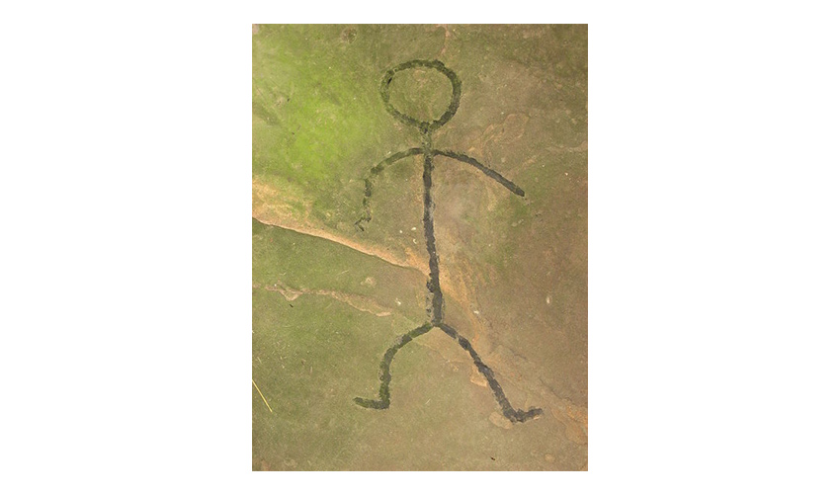[Petroglyph of a human stick figure on the Leo Petroglyph](https://en.wikipedia.org/wiki/File:Leo_Petroglyph,_human_stick_figure.jpg)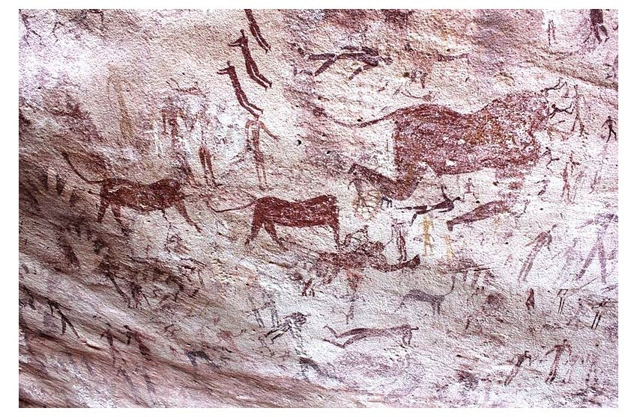[Rock paintings from the Cave of Beasts](https://en.wikipedia.org/wiki/File:Bestias11.JPG)

Being praised for your skill certainly feels great, but it shouldn't be the point of everything you create. Just as you can play basketball with your friends without striving to score like a professional, you can also draw without being good. It's you who decides what the purpose of your art is: proving your value as an artist, sharing a story, or simply having fun.

Web comic strips are a great example of using this medium to share a funny concept. In the strip below there are three different characters, some objects, and some environments, all drawn in very symbolic ways. The characters don't even have eyes! Yet we can easily understand the context of this short story and completely ignore the lack of realistic features. Realism is not important here, and making the characters more realistic wouldn't be an improvement in any way—it would actually draw the attention away from the message.

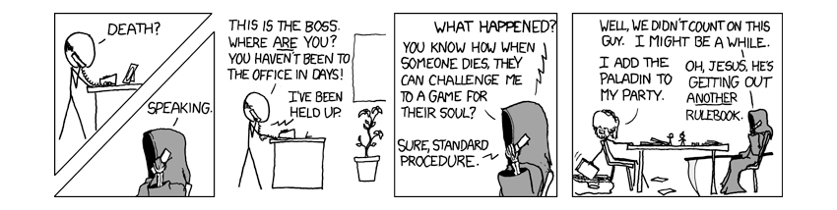[Comic strip by xkcd](https://xkcd.com/393/)

The beauty of symbols lies in their simplicity. The simpler they are, the clearer. That's why they are, and must be, easy to draw. Just stop here, take a pencil (or any other tool you have laying around), and sketch symbols for:

* a cat
* a car
* a spoon
* a smartphone
* a tree

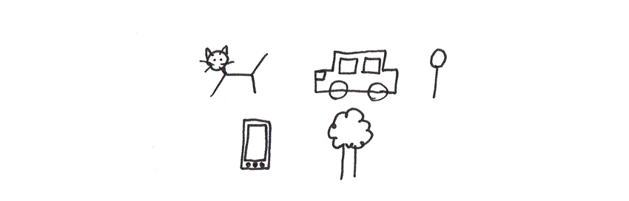

See how easy it is? Once you stop thinking about making the drawings as good as possible, and instead focus on making them as simple as possible, drawing becomes almost effortless and far less stressful. Yes, these sketches are neither "pretty" nor "realistic", but they weren't supposed to be, so that's not a flaw. They're good enough to show the concept, and that makes them good.

Advertisement

### The Production of a Comic

All right, so you know that you can draw, but you may be anxious about one more thing. Comics are created in a certain way. There are grids, panels, speech bubbles, and whatnot... How do you know how to create them?

To be honest, you don't have to know. They all have a certain function in the comic, but they're a tool, not the goal. You can use them as you see fit, using other comics as inspiration rather than as a template. Just look at the xkcd strip again—there are no speech bubbles, just symbolic "arrows" pointing to who's speaking, and one panel doesn't have any frame. Yet the concept is perfectly understandable.

There are no "comic creation" laws that you need to obey when drawing your strips. There's only one rule: the message must be readable to your readers. The means of reaching this goal are completely left to you.

Of course, there are better and worse solutions (good "accessories" should be transparent for the reader), but this is something you can solve on your own while working on your creation.

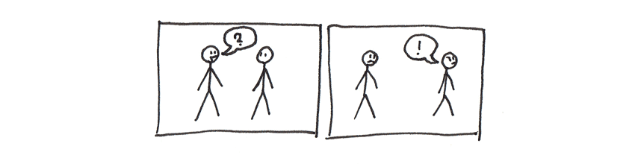Each panel presents a frozen moment in the story, and the speech bubbles show who's saying what. That's basically all you need to know.

## How to Plan the Story

In theory, you can start creating a comic right away, spontaneously, letting your inspiration show you the way. However, in my opinion, creating certain limits is good for creativity—you get some solid ground under your feet, something to build upon. You also get a chance to experiment without any sense of finality, which gives you full creative freedom. Use this guide as you will—these aren't strict rules, just a set of helpful tips.

Of course, the simpler the story, the simpler the plan it needs. If you want to write a short comic strip with two characters talking, or you simply hate planning, just skip to the next section.

### World

First, you need to find out what kind of environment you want to use as a background for your story. It could be simply a location similar to yours, in modern times, but you don't need to limit yourself to what's real. Post-apocalyptic Stockholm with people mutated for superpowers? Medieval village in the middle of nowhere? Magic city in the clouds? No matter how crazy it sounds, if you like the idea, go for it—who can stop you?

You can describe your world in a few sentences to verbally sketch the environment and inspire the ideas for the actual story. For example:

* A college with a dormitory.
* The dormitory is said to be haunted.

Or, if you want a long and complex story:

* Medieval-like world, but not historical.
* A village in the middle of nowhere (five days' horse ride to the closest town).
* The small community is very traditional, conservative, everyone knows each other.
* Children are not educated, they are trained by parents to work in the field only.

### Premise

You don't need to create the whole story at once, but you need to know the "seed" of it, something that lets you start. The easiest way is to create a change in the world you have described earlier, something that forces the characters to act. It can be a dramatic event, or a discovery, something that happens after "... but one day...".

Ok, so what could happen one day?

* Monsters started to come from the forest.
* The protagonist's father died, leaving him with debts.
* A message came from the world under the clouds.
* A student went missing after entering a room.

Don't be afraid to use any clichés; they are popular for a reason—they practically write themselves. And when you're not writing to impress, but for fun, you don't need to worry about being original.

### Characters

The characters are obviously the most interesting, but they're still a tool—they make the story go. You can start with a character and create a story for them, but it's usually easier to go the other way around.

You need a few characters:

* The main character: we see the world from their perspective (there can be more than one).
* The secondary characters: they affect the actions of the main character in some way, helping you shape the story.
* The background characters: they can be described collectively, e.g. students, villagers. They fill the world to make it less empty, but they do little to the story as individuals.

This is a very simplified explanation, but it should be enough to start writing without getting caught in technicalities. Describe your characters in a few words, trying to capture their role and relation to each other rather than looks.

In the story about a haunted dormitory, for example, the list may look like this:

* The main character: a new student, cheeky, prefers acting over thinking.
* The secondary character I: best friend of MC, rational, emotionally stable.
* The secondary character II: a fellow student, the crush of MC.
* The background characters: parents, other students, teachers.

## How to Plan the Style of the Comic

This is the most pleasant part, because you can have fun with drawing without any pressure to reach any specific goal. You just need to create something that will let you present the story.

You don't have to worry about creating your own style—you already have it! Drawing style, in its most basic definition, is the way you simplify reality. You can make the style more unique by working on it consciously, but then you need to remember about consistency—the style must be repeatable, not accidental.

### The Base

You don't know what you're capable of until you try. So, try! Sketch a few instances of:

* a human
* an animal
* a plant
* an inanimate object
* a vehicle
* background elements

Don't stop on the first sketch. What can you modify to make the objects clearer? How can you distinguish the characters? Make sure you can easily replicate the results; nothing should be created by accident.

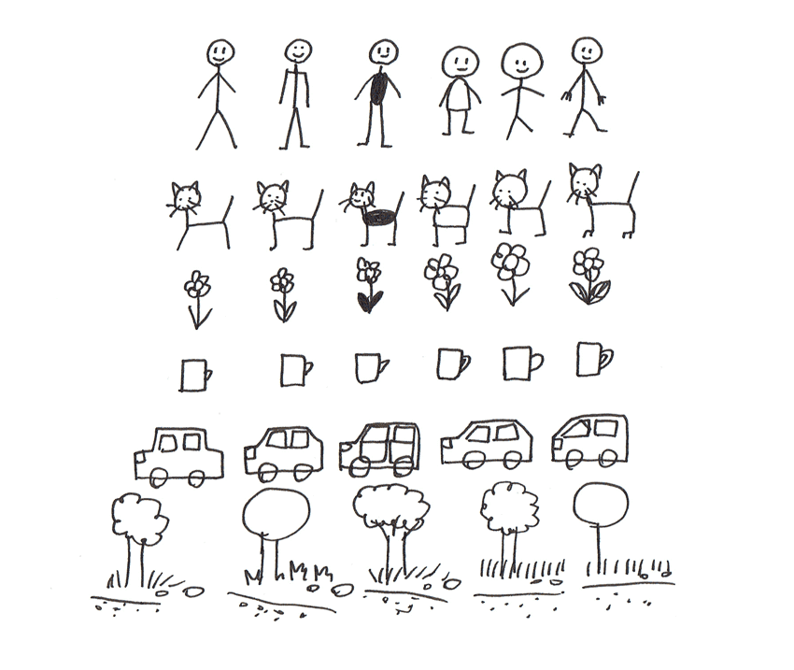

### Motion

Your characters are going to move during their adventures, so you must invent some way to show their movement. See how you can draw these basic poses:

* turned to the side
* walking
* running
* sitting
* lying

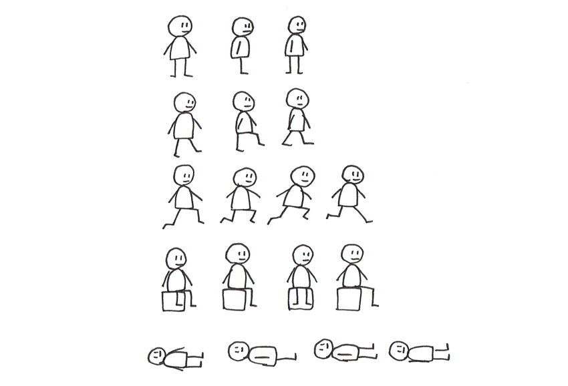

### Expressions

To better understand the story, the reader must be able to read the emotions of the characters. Although human expressions are very complex, they can be easily pictured with symbols. See how you can show the basic emotions in your characters with both facial expressions and gestures:

* blank
* happy
* angry
* sad
* ashamed
* suspicious

It helps if you make the same face yourself while drawing!

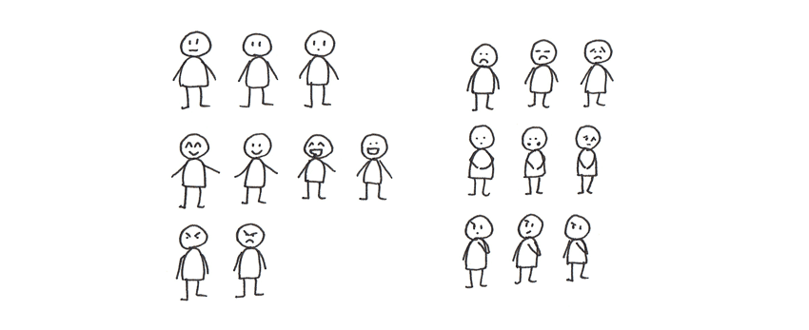

If you want to use more emotions, this tutorial will be very helpful:

* [[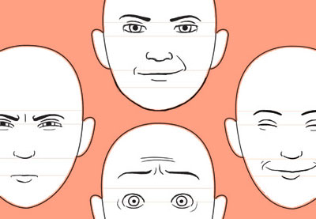](https://design.tutsplus.com/tutorials/human-anatomy-fundamentals-mastering-facial-expressions--cms-21140)](https://design.tutsplus.com/tutorials/human-anatomy-fundamentals-mastering-facial-expressions--cms-21140)

**[DRAWING](https://design.tutsplus.com/tutorials/human-anatomy-fundamentals-mastering-facial-expressions--cms-21140)**

**[Human Anatomy Fundamentals: Mastering Facial Expressions](https://design.tutsplus.com/tutorials/human-anatomy-fundamentals-mastering-facial-expressions--cms-21140)**

[Joumana Medlej](https://design.tutsplus.com/tutorials/human-anatomy-fundamentals-mastering-facial-expressions--cms-21140)

### Speech Bubbles

Although speech bubbles are almost invisible to the reader, you, as a creator, must draw them in some way. Experiment to see what's easiest for you—what shape the bubble should have, and what font should be used for the captions. What happens when a speech bubble and a character overlap? Or is this not allowed to happen? Decide it all now.

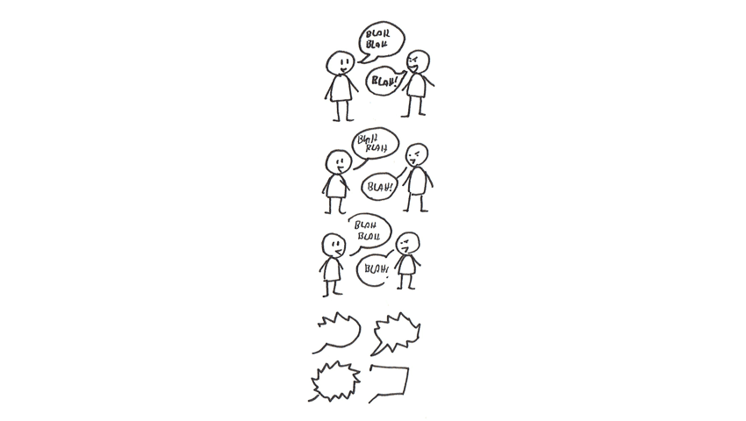

* [[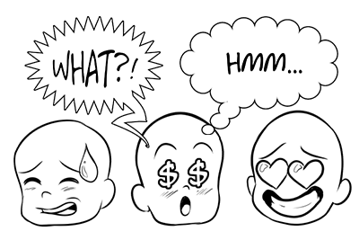](https://design.tutsplus.com/tutorials/how-to-create-speech-bubbles-and-comic-effects-in-adobe-illustrator--cms-24764)](https://design.tutsplus.com/tutorials/how-to-create-speech-bubbles-and-comic-effects-in-adobe-illustrator--cms-24764)

**[CARTOON](https://design.tutsplus.com/tutorials/how-to-create-speech-bubbles-and-comic-effects-in-adobe-illustrator--cms-24764)**

**[How to Create Speech Bubbles and Comic Effects in Adobe Illustrator](https://design.tutsplus.com/tutorials/how-to-create-speech-bubbles-and-comic-effects-in-adobe-illustrator--cms-24764)**

[Sara Berntsson](https://design.tutsplus.com/tutorials/how-to-create-speech-bubbles-and-comic-effects-in-adobe-illustrator--cms-24764)

### Style

Another thing: what style do you want to use in a technical sense? Is everything going to be drawn with a pencil? Or do you want to use a simple way of inking? Are you planning to use colors or shading? Test it all to see the effects in practice and choose the best way for you.



### Characters

Once you have chosen the style for your comic, design your characters using it. Make them clearly recognizable and use the elements of their looks to accentuate their personality and role in the story.

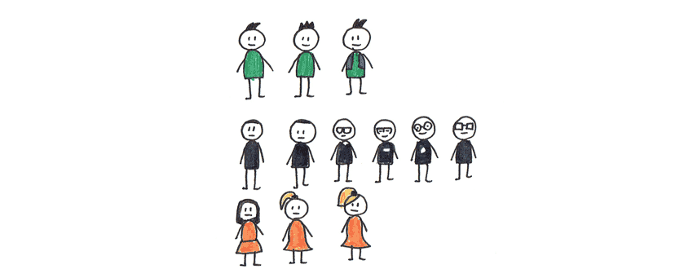

## 1. How to Sketch the Comic

### Step 1

Time for the actual story! To create it without caring about the layout, we can sketch it first. This way you'll be able to create without any pressure to make it look good right away.

Don't start with a grid. The panels will have various sizes depending on what's happening in them, and you don't know it yet. So instead, draw the panels side by side, step by step.

But enough with technicalities. The problem with writing a story is that it usually starts before any exciting thing happens. So your first panel is supposed to lead to that big thing, even though you may not be sure exactly what that big thing is going to be yet. So don't get stuck trying to create a perfect setup right from the first panel—start with the big event!

Focus on the story for now, not on the visuals. You can differentiate the characters by adding short labels to them.

### Step 2

Let the story unravel for a moment, to get to know the characters better through their actions and interactions. Keep in mind that you don't need to follow your plan strictly—if you get a better idea in the process, go for it!

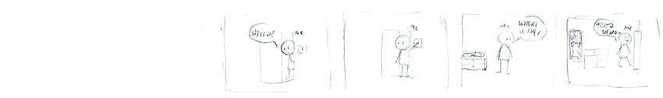It doesn't need to be clean, just make sure you can understand what's going on

### Step 3

Now, go back in time. How far? It depends on you. You can present the world in a "normal" setting or go straight to explaining what has led directly to the event. Starting with an establishing shot can be a good idea for the first panel:

* [[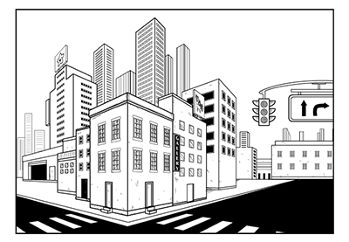](https://design.tutsplus.com/tutorials/make-an-establishing-shot-using-the-perspective-grid-tool-in-adobe-illustrator--cms-24181)](https://design.tutsplus.com/tutorials/make-an-establishing-shot-using-the-perspective-grid-tool-in-adobe-illustrator--cms-24181)

**[COMICS](https://design.tutsplus.com/tutorials/make-an-establishing-shot-using-the-perspective-grid-tool-in-adobe-illustrator--cms-24181)**

**[Make an Establishing Shot Using the Perspective Grid Tool in Adobe Illustrator](https://design.tutsplus.com/tutorials/make-an-establishing-shot-using-the-perspective-grid-tool-in-adobe-illustrator--cms-24181)**

[Sara Berntsson](https://design.tutsplus.com/tutorials/make-an-establishing-shot-using-the-perspective-grid-tool-in-adobe-illustrator--cms-24181)

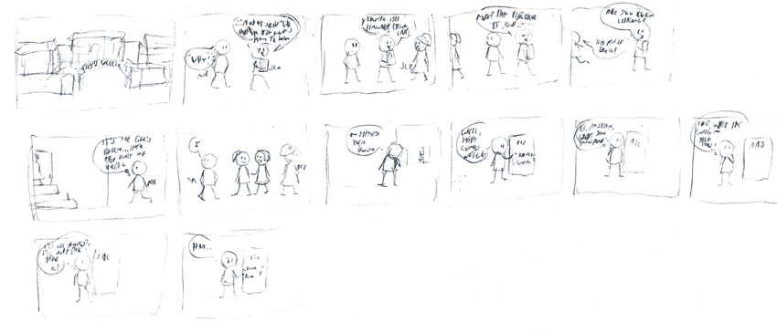

### Step 4

You have the beginning, you have the starting point of the story, and now you can simply write it! You can go continuously from there, or keep jumping from event to event, filling the spaces by going back in time. It will depend on how complete the story is in your mind.

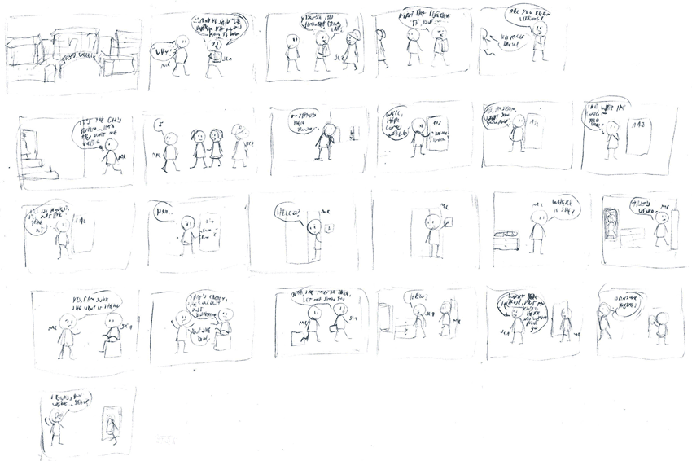

## 2. How to Plan the Comic Layout

As I said before, the panels are simply a tool for presenting the story. They show the flow of time, the actual events we should pay attention to one by one. But their shape and size have a function as well, so they shouldn't be ignored.

Go back to the comic and analyze each panel. What elements are the most important? What do you want to make the readers see first? Crop the panels to accentuate the message. When you're done, number the panels.

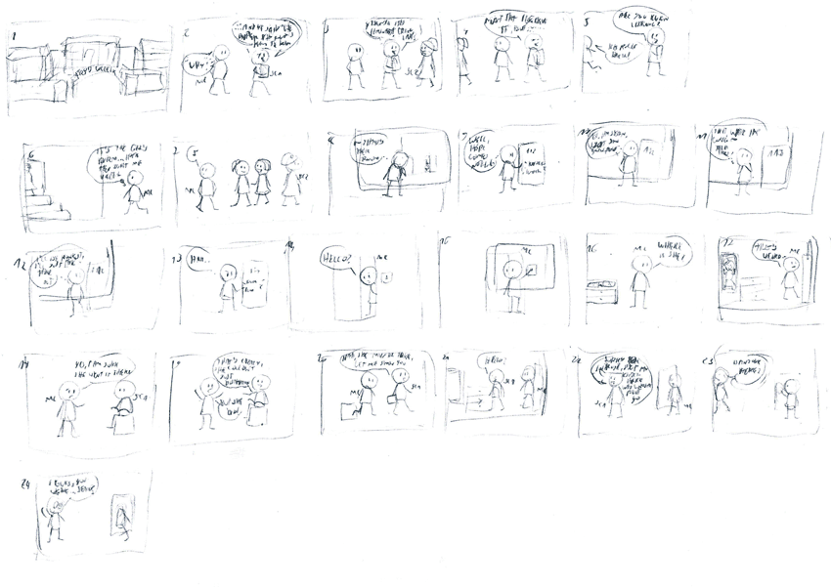

You can learn more about the power of composition here:

* [[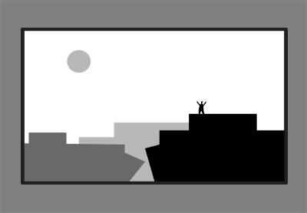](https://design.tutsplus.com/articles/how-to-create-interesting-composition-in-drawing--cms-27402)](https://design.tutsplus.com/articles/how-to-create-interesting-composition-in-drawing--cms-27402)

**[DRAWING THEORY](https://design.tutsplus.com/articles/how-to-create-interesting-composition-in-drawing--cms-27402)**

**[What Is Composition, and Why Is It So Important in Drawing?](https://design.tutsplus.com/articles/how-to-create-interesting-composition-in-drawing--cms-27402)**

[Monika Zagrobelna](https://design.tutsplus.com/articles/how-to-create-interesting-composition-in-drawing--cms-27402)

## 3. How to Draw the Comic

### Step 1

You have the whole story, but it's just a sketch. To make it easier to follow, redraw the whole thing on a new sheet of paper.

First, sketch the grid according to the number of panels you need. You can adjust their shape and size depending on what's happening in the specific panel.

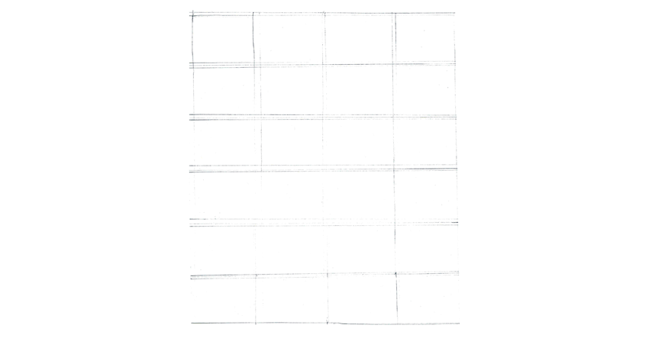

### Step 2

Now, sketch the characters, this time including their full visual side and the facial expressions. Make sure the speech bubbles have enough space for the captions.

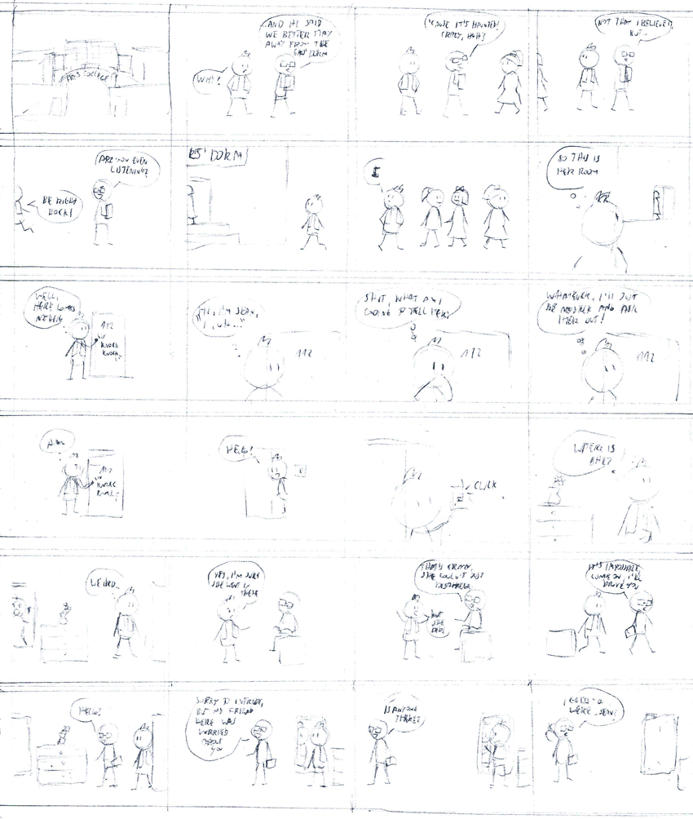Notice how the old cropped panels fill the whole new panels, changing the scale of the content

### Step 3

Time to add a pinch of finality to the whole comic. Inking is a great way to make the lines clean and definite. You can use a simple fine liner to accentuate the lines and text.

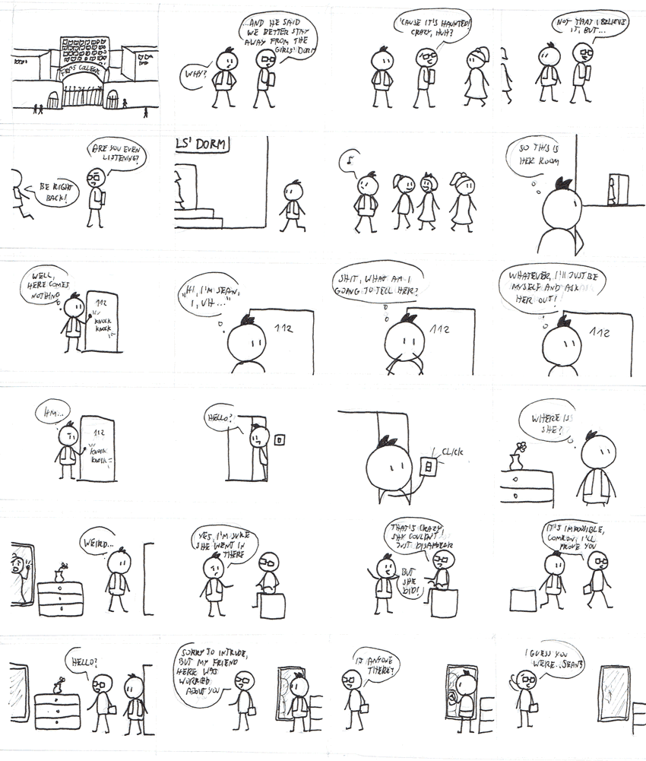

### Step 4

Take an eraser and carefully remove the sketch. Make sure the ink is dry before you start!

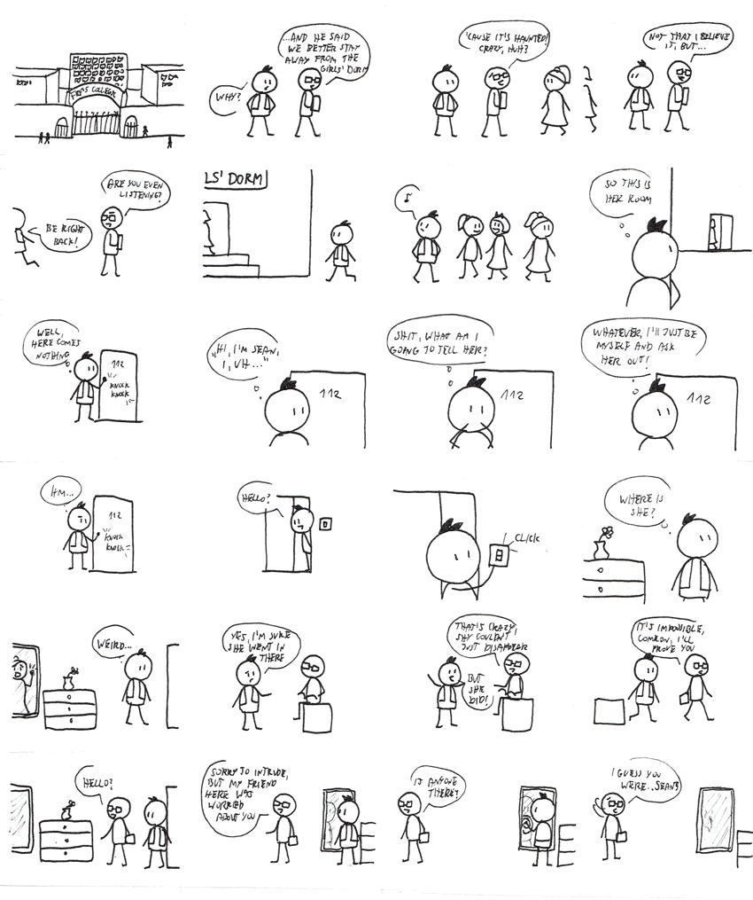

### Step 5

If you decided to use colors as well, this is the time to add them.

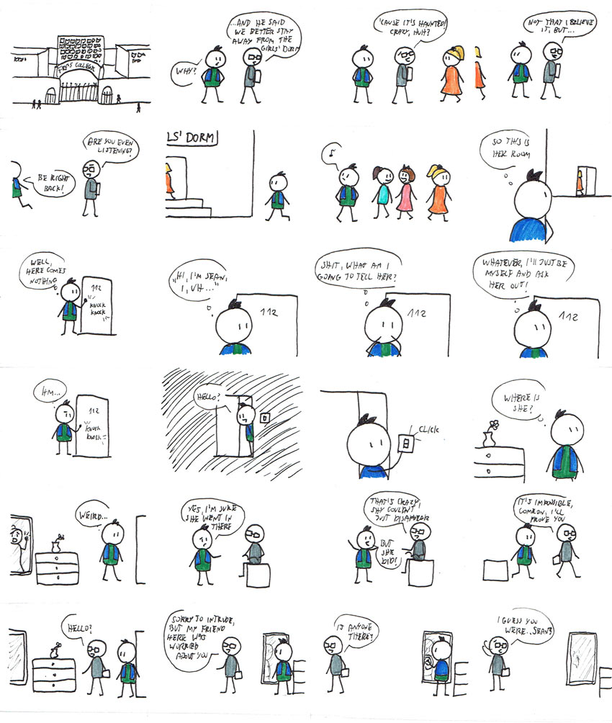

### Step 6

Finally, add borders to the panels.



## Good Job!

Your very own comic page is finished! Isn't it great? No matter how it looks, you can be proud of yourself—you've created something personal, something nobody else could create. You let your story come to life, become real. Maybe it's not a masterpiece, maybe there are prettier comics out there, but who cares? This is your creation, and you had fun!

If you want to share it online, don't forget to change the size of the scan/photo to something smaller than the original. The comic page should be viewed as a whole, without scrolling too much to the sides or up and down. If you want to learn more about creating comics, you'll love these posts as well:

Retrieved October 18, 2019 from <https://design.tutsplus.com/tutorials/art-therapy-draw-a-stick-figure-comic--cms-29760>